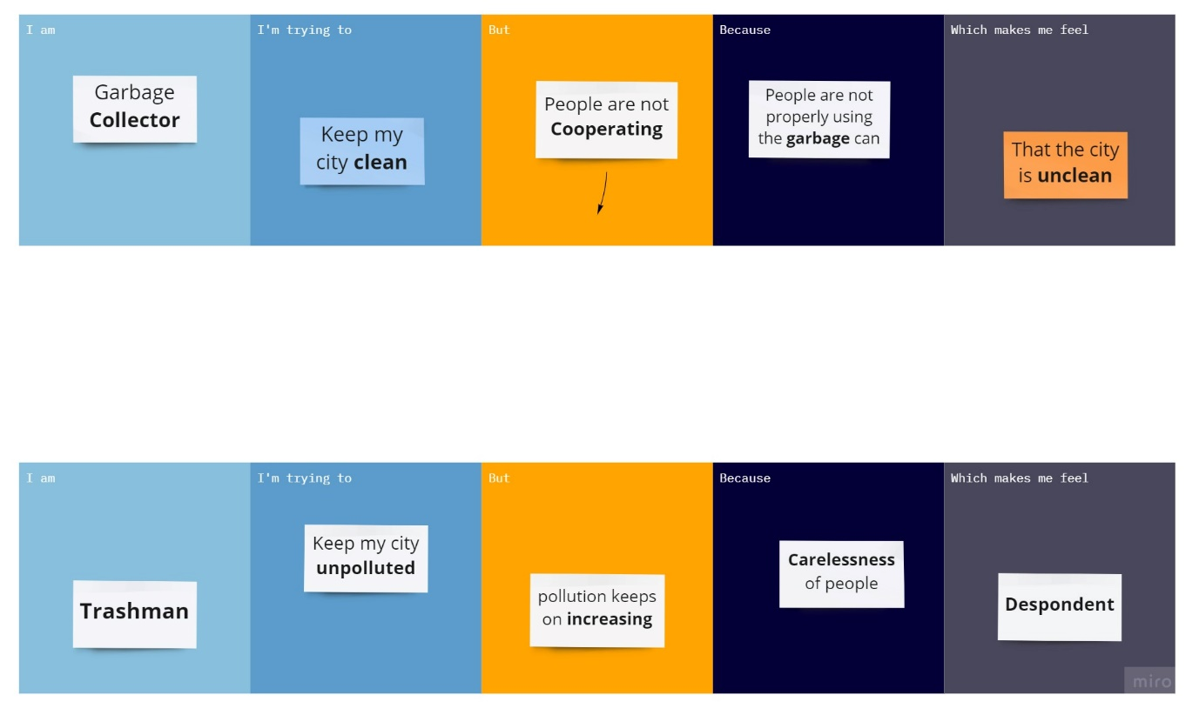

|  |  |  |  |  |  |
| --- | --- | --- | --- | --- | --- |
| **Problem Statement(PS)** | **I am**  **(Customer)** | **I’m trying to** | **But** | **Because** | **Which makes me feel** |
| **PS-1** | Garbage collector | Keep my city clean | Peoples are not cooperating | People are not properly using the garbage can | The city is un clean |
| **PS-2** | Trashman | Keep my city unpolluted | Pollution keeps on increasing | Carelessness of people | Despondent |